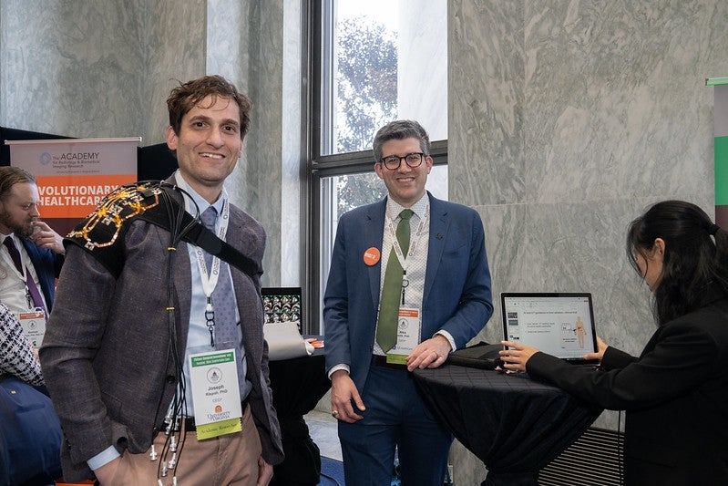

*Joseph Rispoli, PhD (left), a member of the 2024-25 class of The Council of Early Career Investigators in Imaging (CECI²), at The Academy Medical Imaging Technical Showcase in Washington, D.C. this past March.*

**Joseph Rispoli, PhD, Inducted into Council of Early Career Investigators in Imaging***By Henry Lin-David*

The University of Virginia’s Joseph Rispoli, PhD, associate professor of radiology and medical imaging, was inducted into a prestigious national council of early career imaging researchers earlier this year.

Dr. Rispoli is one of 35 investigators who make up the 2024-25 class of The Council of Early Career Investigators in Imaging (CECI²), which was created by The Academy for Radiology and Biomedical Imaging Research. In addition to recognizing these individuals, the initiative helps these imaging researchers take part in advocacy for medical imaging research funding. This past March, members of the council participated in advocacy events and roundtables in Washington D.C. as part of The Academy Medical Imaging Technical Showcase.

As part of the program, Dr. Rispoli will take part in a virtual events throughout the year focused around topics about medical imaging research. These events are planned by the council’s planning committee, which includes UVA’s Natasha Sheybani, PhD, assistant professor of biomedical imaging, who serves as co-chair.