[caption id="attachment_15251" align="aligncenter" width="1024"]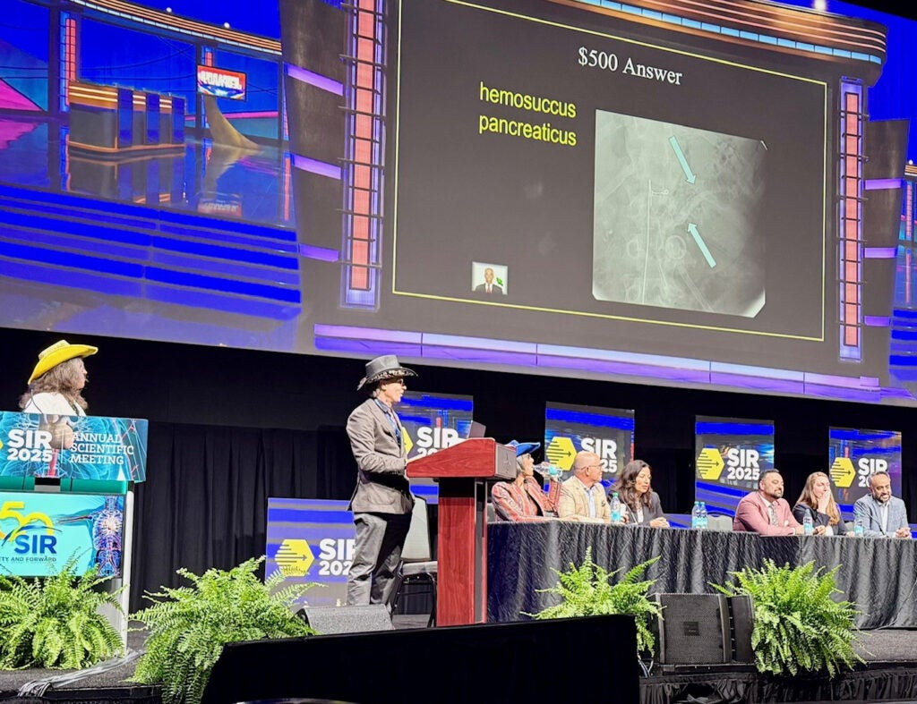 Professor Ziv Haskal, MD hosts a rousing game of IR Jeopardy at the Society of Interventional Radiology's 2025 Annual Scientific Meeting.



A strong cohort from the University of Virginia's**Department of Radiology and Medical Imaging** headed west to contribute to the Society of Interventional Radiology's 2025 annual meeting in Nashville, Tennessee.

From March 29 to April 2, faculty members and trainees contributed to a variety of events: panels, presentations, and even a few rounds of IR Jeopardy. ([Click here for a schedule of those events.](https://med.virginia.edu/radiology/wp-content/uploads/sites/191/2025/04/SIR-Booklet-002.pdf)) Below is a list of department presenters:

**Trainees**

* **Shahrzad Azizaddini, MD** (PGY-6, IR-Independent)
* **Warren A. Campbell, MD** (PGY-2, IR-Integrated)
* **Vishnu M. Chandra, MD** (PGY-6, IR-Integrated)
* **Christina Dalzell, MD** (PGY-3, IR-Integrated)
* **Torikai Hideyuki, MD** (Fellow, Pediatric Radiology)
* **Viknesh Kasthuri** (incoming PGY-1, IR-Integrated)
* **Megan K. H. Powell** (UVA medical student)

**Faculty Members**

* **J. Fritz Angle, MD**
* **Ziv J. Haskal, MD**
* **Alan H. Matsumoto, MD, MA**
* **Daniel Sheeran, MD**
* **Amy C. Taylor, MD, MBA**
* **Luke R. Wilkins, MD**