**Completed MRI Suite Expansion Offers Advantages for Patients, Providers***By Henry Lin-David*

On Monday, April 14, a small group convened within the University of Virginia’s University Medical Center to witness a special event: a ceremonial ribbon-cutting and tour of the long-awaited MRI suite expansion.

“It really is a spectacular facility,” said Colin Derdeyn, MD, chair of UVA’s Department of Radiology and Medical Imaging. “It’s going to have a great impact.”

One particularly meaningful upgrade is the incorporation of a 4th MRI scanner within the hospital. Before the expansion, the MRI suite contained just 3 scanners for the entire medical center. For nearly 4 years, the department has utilized an additional trailer-based MRI scanner behind the hospital – though this has created inefficiencies with staffing and patient flow.

Now with the 4th MRI scanner located in the hospital, patient imaging workflow “will significantly improve,” said James Carnes, UVA Radiology’s medical center administrator. Plus, the expansion includes a “shell space” for a potential 5th MRI scanner in the future, which would increase capacity even further.

Besides scanner space, the MRI suite expansion offers other benefits. These include additional preparation and recovery space for patients, as well as a designated anesthesia support area for patients with sedation needs.

This project has been a long time coming. The expansion occupies space that formerly held the Interventional Radiology suite, which moved to the South Tower in early 2020. But although planning began nearly 6 years ago, construction met an unexpected roadblock.

“The project was originally scheduled to commence in the fall of 2020 and the expansion to be open in 2022,” said Carnes. “But the pandemic intervened and the project was significantly delayed.”

Today, the expanded MRI suite is finally functional and seeing patients – thanks to the multi-year work of several individuals and teams. Among them: UVA’s MRI team and off-site anesthesia team, UVA Capital Construction & Renovation, Siemens, UVA Radiology’s Director of Inpatient Imaging Rich Hooper, Carnes, and many other individuals across UVA Health and beyond. And although the project faced uncertainties, it now has the chance to impact patients and providers alike.

“I’m relieved and thankful that we’re finally able to open the expanded MRI suite to facilitate patient care and to improve workflow for our MRI team and the off-site anesthesia team,” said Carnes. “And [I’m] sincerely grateful to the organization’s support of the project.”

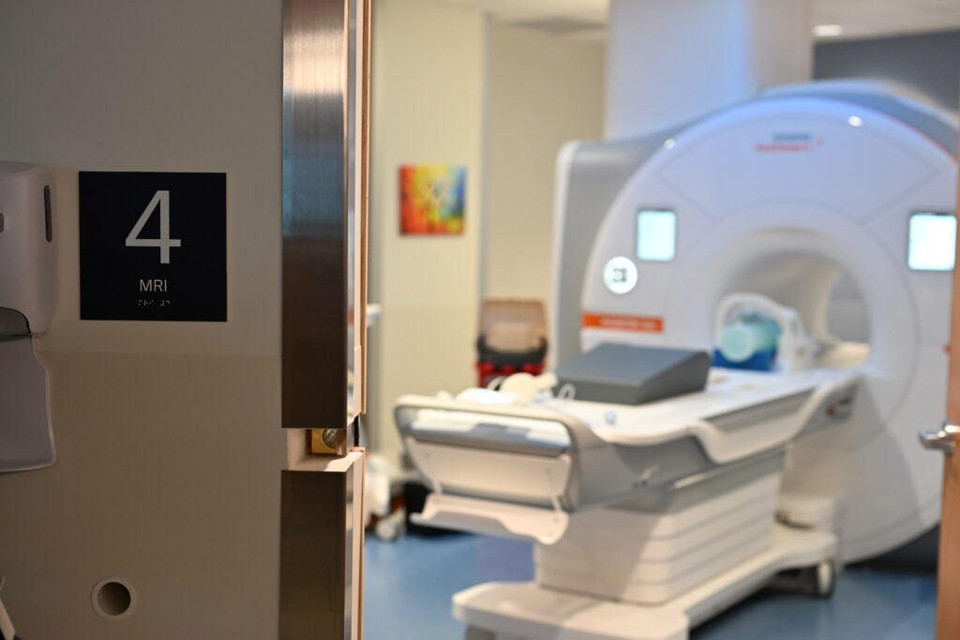 The MRI suite expansion incorporates a 4th scanner within the medical center, which will significantly improve patient imaging workflow.

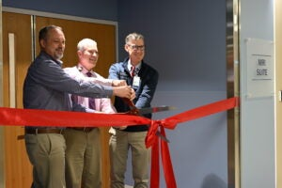

From left to right: UVA Radiology's Rich Hooper; James Carnes; and Colin Derdeyn, MD at the ribbon cutting ceremony celebrating the new MRI suite expansion at UVA's University Medical Center.

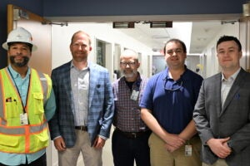   
From left to right: Nathaniel Brown, construction administration manager at UVA Capital Construction & Renovation; David Turner, vice president at Kjellstrom and Lee (general contractor); James Loman, project manager at UVA Capital Construction & Renovation; Hunter Durrer, construction adminstration manager at UVA Capital Construction & Renovation; and John Keefe, project manager at Kjellstrom and Lee.

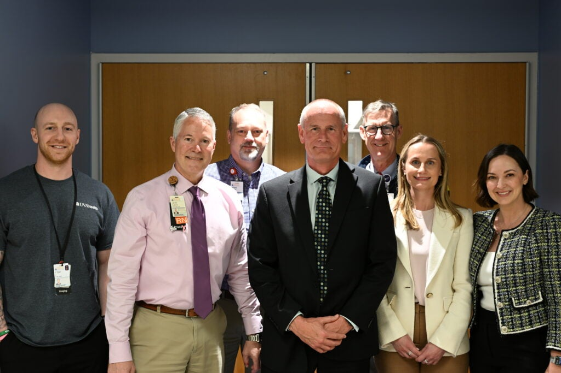

Members of UVA Radiology and Siemens Medical. From left to right: Tyler Johnson, UVA Radiology MRI imaging supervisor; James Carnes, RN, UVA Radiology medical center administrator; Rich Hooper, UVA Radiology director of inpatient imaging; Stuart Clarkson, Siemens Medical MRI area vice president; Colin Derdeyn, MD, UVA Radiology chair and professor; Jessica Barr, Siemens Medical key account executive; and Sara Bremer, Siemens Medical director of commercial operations.[/caption]