GHLT article captions:

*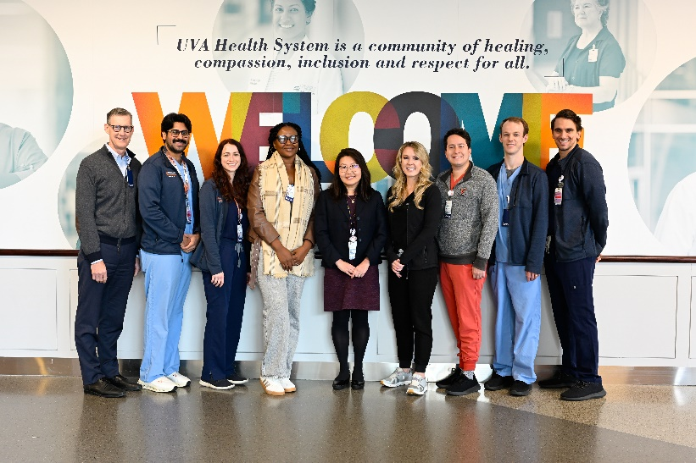*

*From left to right: Department Chair Colin Derdeyn, MD; UVA Global Health Leadership Track residents Vatsal Lal, MD, and Julia Kariher, MD; visiting resident Catherine Kavishe; GHLT Program Director Jenni Pierce, MD; UVA Global Health Leadership Track residents Olivia Richardson, MD, George Cheeseman, MD, Andrew Westberry, MD, and Connor Sleeth, MD*

*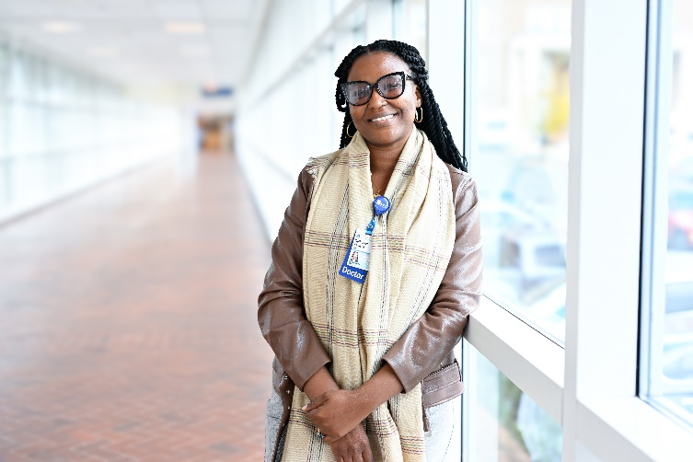*

*Catherine Kavishe*

**

*At the reception, Kavishe was joined by faculty members from her home institute of Muhimbili Orthopaedic Center in Tanzania*

*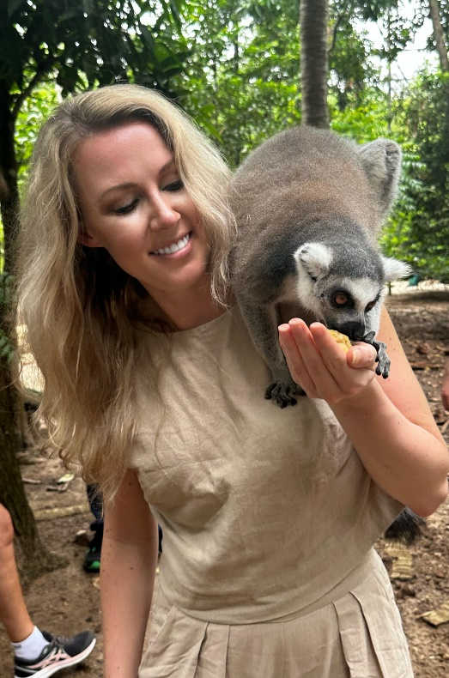*

*Olivia Richardson, MD traveled to Tanzania as part of UVA Radiology’s Global Health Leadership Track.*

*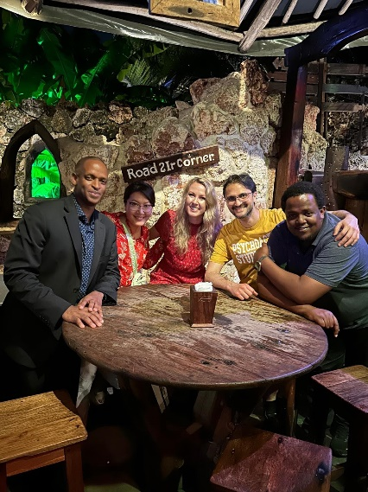*

*Dr. Richardson’s trip was made possible through UVA’s collaboration with the organization Road2IR.*

*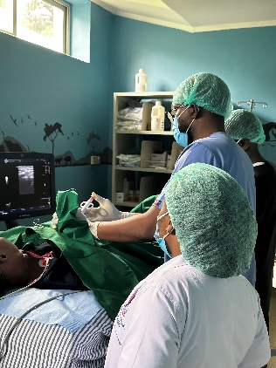*

*An IR procedure at Muhimbili National Hospital*