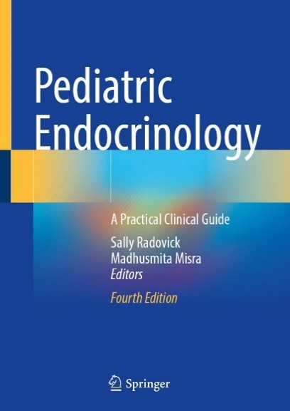Dr. Madhusmita (Madhu) Misra is the Chair of Pediatrics at UVA and the Physician-in-Chief of UVA Health Children’s. As a physician scientist, Dr. Misra has been engaged in research related to neuroendocrine, neuropsychiatric, metabolic and bone consequences of conditions spanning the weight spectrum from anorexia nervosa to obesity for over two decades, and her work has been paradigm shifting in defining management strategies for low bone density in adolescent and young adult women with functional hypothalamic amenorrhea. She was recently awarded an R01 grant from the NICHD (with Dr. Karen Miller at Massachusetts General Hospital) to examine the impact of sequential use of romosozumab (as a bone anabolic agent) and zoledronic acid (an antiresorptive) in improving bone outcomes in young women suffering from functional hypothalamic amenorrhea. She has been consistently funded by the NIH since 2000. This is her seventh R01 grant.

Further, Dr. Misra has just published a book “Pediatric Endocrinology: A Practical Clinical Guide, 4th Edition” that she has co-edited with Dr. Sally Radovick. In addition, Dr. Misra has over 250 original research publications to her credit, and has authored over 100 chapters, reviews and position statements. She has served in many national leadership roles, including as the President of the Pediatric Endocrine Society. Since joining UVA, Dr. Misra has worked on advancing the clinical enterprise by fostering collaborations across and beyond UVA Health Children’s, developed a strong research infrastructure and hired young investigators to establish a pipeline of research within the Department of Pediatrics, worked on enhancing training programs in Pediatrics and advancing community engagement.