**Cancer Center Seminar**

**Hybrid Event**

**Friday, January 24, 2025**  
**12:30- 1:30**

*Lunch will be served from noon -12:30 p.m.

**Pinn Hall, Room 1014\***  
or

[Click here to join via Zoom](https://virginia.zoom.us/j/93329958624?pwd=yNPteTNQ3bDTOzux4lBaxQi1Zji31f.1" \o "Click here to join via Zoom)

Meeting ID: 933 2995 8624

Passcode: 211462

**“AI & Oncology: Managing the Tsunami of Medical Information and a Peek into the Future”**

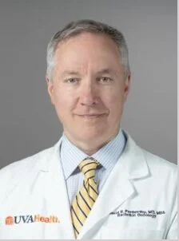

**David R. Penberthy, MD, MBA**  
Associate Professor and Medical Residency Program Director of Radiation Oncology

**Host: Roger Abounader, PhD, MD**

If you have questions or feedback, or if you would like to host a seminar in the future, please email Gabrielle Schrecongost at [gjs2eb@uvahealth.org](mailto:gjs2eb@uvahealth.org) or Roger Abounader [ra6u@virginia.edu](mailto:ra6u@virginia.edu?subject=),  for available dates. Potential hosts are strongly encouraged to invite diverse speakers.

[UVA Comprehensive Cancer Center's Statement on Diversity](https://uvahealth.com/services/cancer/about)   
The complete Seminar Series schedule is available [online](https://med.virginia.edu/cancer-research/seminars-events/).