On Sunday, October 27th, CVRC members ran the Haunted Heart 5K, a charity race to raise money for the American Heart Association (AHA). The event was organized and sponsored by Cardiovascular Training Grant participants. Approximately forty participants, many in Halloween costumes, ran the route. Julia Bresticker, an MD/PhD student in the lab of Fred Epstein, PhD, placed first in the race. Bill Petri, MD, PhD, was voted to have worn the best costume, alongside Michael Lemke, a PhD student in the lab of Thurl Harris, PhD, and Maddie Deye. The event raised approximately $1,500 for the AHA. A group of people running on a brick path

Runners prepare for the start of the race.

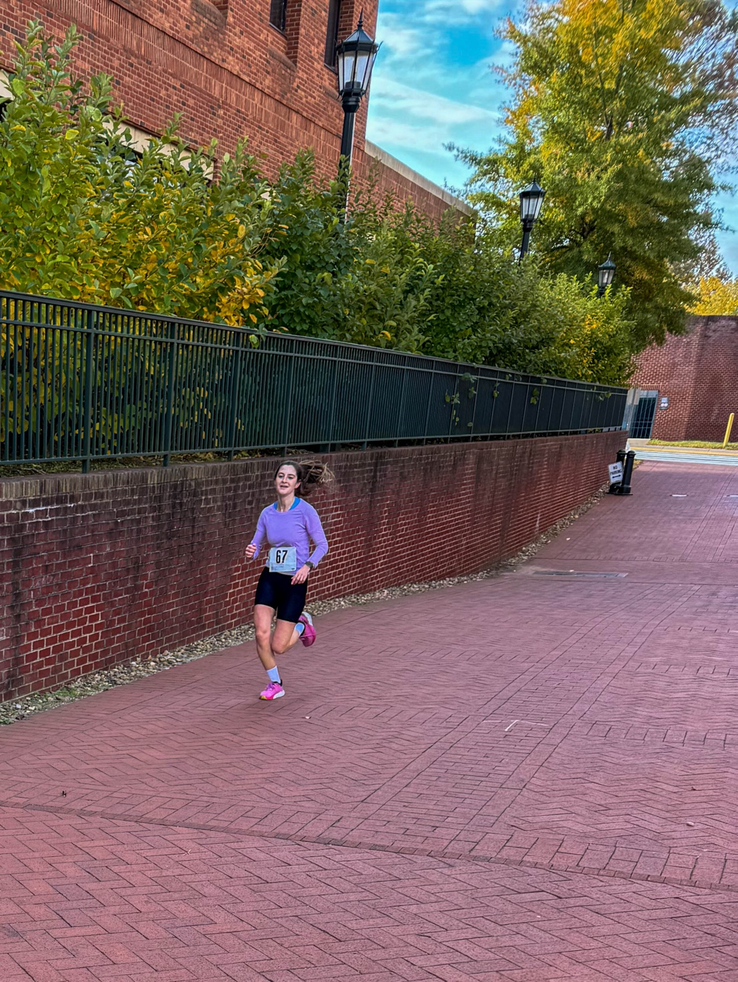

Julia Bresticker, winner of the 5K race.

Bill Petri, MD, PhD, costume contest winner

Michael Lemke (right) and Maddie Deye (left), costume contest winners.