

**The Department of Pediatrics invites you to**

***The Third Annual Nancy McDaniel Lectureship on Women in Leadership***

**October 28, 2024**

**4:00 PM--5:00 PM Pinn Hall Auditorium**

**Reception to follow**

***Keynote Lecture:***

**“Pathways to Progress: Advancing Women's Careers in Academic Medicine”**

**Miriam A. Bredella, MD, MBA**

Dr. Bredella is Associate Dean for Translational Science and Director of the Clinical and Translational Science Institute at NYU Langone Health. She is also a musculoskeletal radiologist and professor of radiology and vice chair for strategy in the Department of Radiology at NYU. She holds an MBA from MIT/Sloan School of Management. Before joining NYU, Dr. Bredella was a professor of radiology at Harvard Medical School and a musculoskeletal radiologist at the Massachusetts General Hospital (MGH) where she served as vice chair for faculty affairs. She established a department-wide faculty mentoring program which was awarded the Program Award for Culture of Excellence in Mentoring from Harvard Medical School. She directed the MGH-wide Center for Faculty Development overseeing the Offices for Women’s Careers, Clinical Careers, and Research Careers, the Offices for Well-Being, and Senior Faculty Affairs, which she established. During the COVID-19 pandemic, Dr. Bredella implemented multiple hospital-wide and nation-wide initiatives to support women faculty and trainees, which received the 2020 Innovative Initiatives Award from the Boston Women’s Workforce Council, the 2023 AAMC Group on Women in Medicine and Science Leadership Award. She was awarded the Shirley Driscoll Dean's Leadership Award for the Enhancement of Women's Careers from Harvard Medical School. Academy of Medicine.

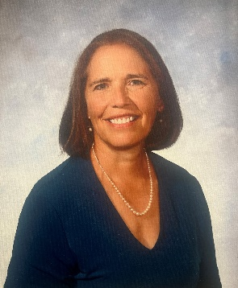

**Nancy L. McDaniel, MD**

Nancy L. McDaniel, M.D. grew up in Virginia and attended the University of Virginia for both undergraduate and medical school. She completed her residency at Case Western University in Ohio and returned to UVA for a pediatric cardiology fellowship. She joined the UVA faculty in 1989. Dr. McDaniel retired from the University of Virginia, Department of Pediatrics in March 2018. During her time at the University of Virginia, she was an active clinician seeing infants, children, and adolescents with known heart conditions as well as seeing children referred from general practice. Early in her career, she continued basic laboratory research during her fellowship on the mechanisms of smooth muscle relaxation under the mentorship of Richard Murphy, Ph.D. Trainee education was an important part of her career with clinical skills education for students, residents, and fellows. She served as the first Medical Director for the 7 Acute Service, was the initial Medical Director for the Children’s Medical Center, and was very active in establishing the University of Virginia Children’s Hospital. She was an integral part of the selection of the architect and design firms for the Battle Building. She served as the Vice Chair of the Department from 2002 until her retirement.