UVA Medicine in Motion newsletter

Starr Hill Pathway Program meets UVA Health

Dr. Stefanie Redemann (Associate Professor, Molecular Physiology and Biological Physics) and Dr. Kamilla Esfahani (Associate Professor of Anesthesiology) successfully completed their JEDI Capstone Project by involving UVA Health with the Starr Hill Pathways program. The Starr Hill Pathways is an initiative of the Equity Center at UVA. For two weeks, students of Albemarle County and Charlottesville City explore career opportunities in various fields. Five Clinical Departments and 6 Basic science labs volunteered their time and used creative ways to introduce middle schoolers about what it is we do from genetically modifying cells to intubating patients. The JEDI leaders and individuals from their departments went above and beyond to ensure the students would have an engaging and exciting experience. Many thanks to the Office of Diversity, Equity, and Inclusion for their support, and a big shout out to the Clinical Departments and Basic Science labs and their leaders:

Dr. Jackie Zillioux, Department of Urology
Dr. Tanvir Rizvi, Department of Radiology
Dr. Sarah Dalrymple, Department of Family Medicine
Alanna Baker, Department of Psychiatry
And the Department of Anesthesiology

The Department of Molecular Physiology and Biological Physics:
The Levental Lab
The Qi Lab
The Bao Research Group
The Redemann Lab
The Ai Lab
The Zimmer Lab

More about the 2024 program and the student’s experiences in the lab can be found here: https://news.virginia.edu/content/uno-young-persons-game-and-other-starr-hill-lessons

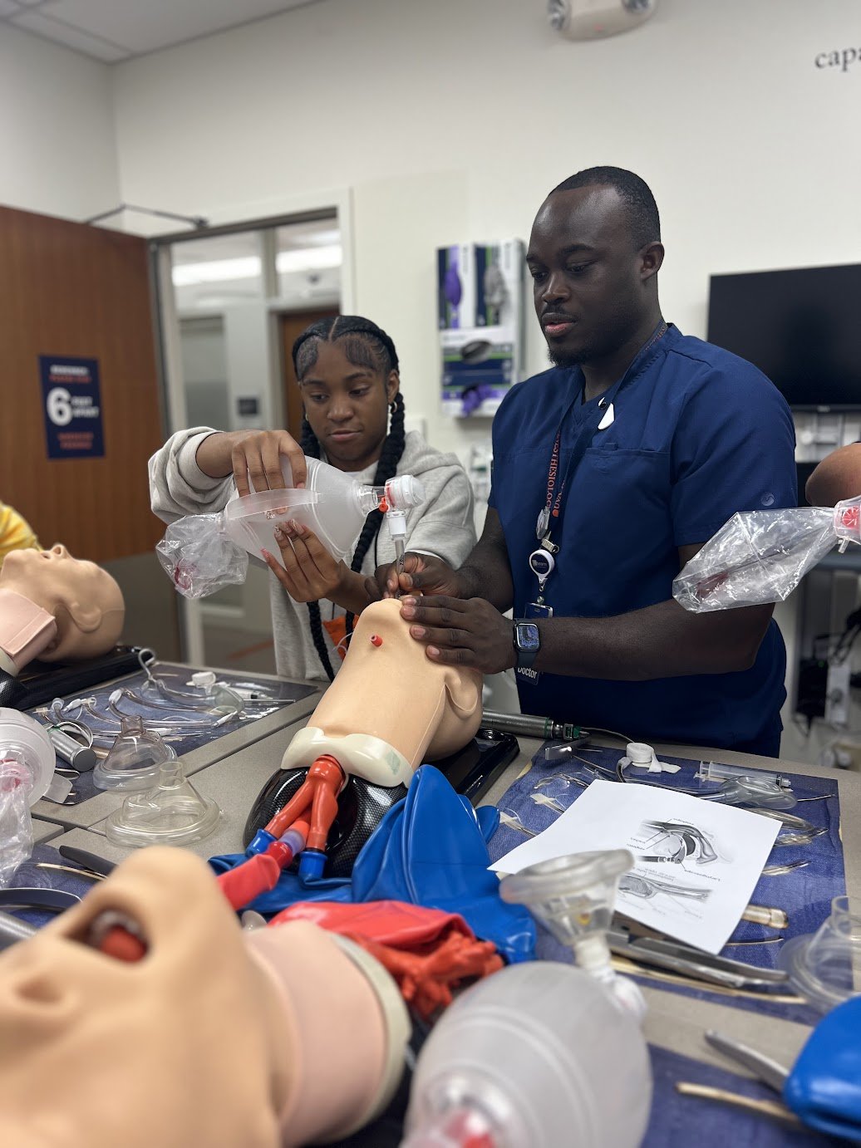
Dr. Richard Beckett-Ansa (PGY-2 Department of Anesthesiology) in the Sim Lab

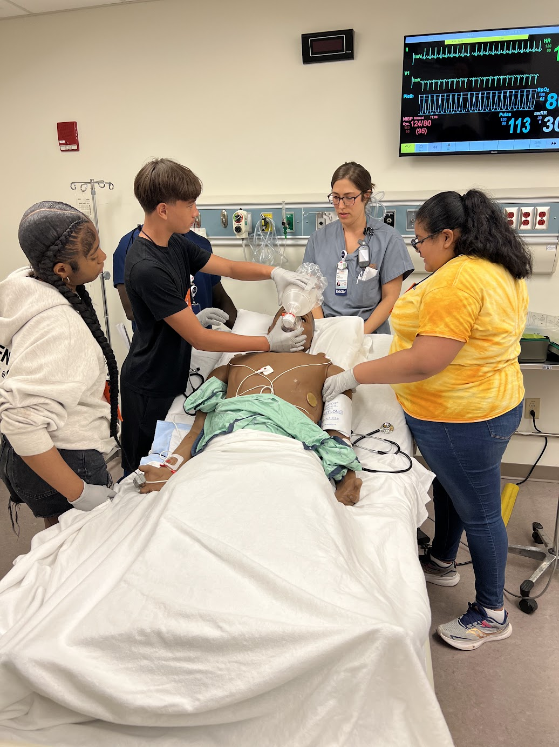
Dr. Alisa Wilkinson and students running through an asthma attack scenario in the Sim Lab

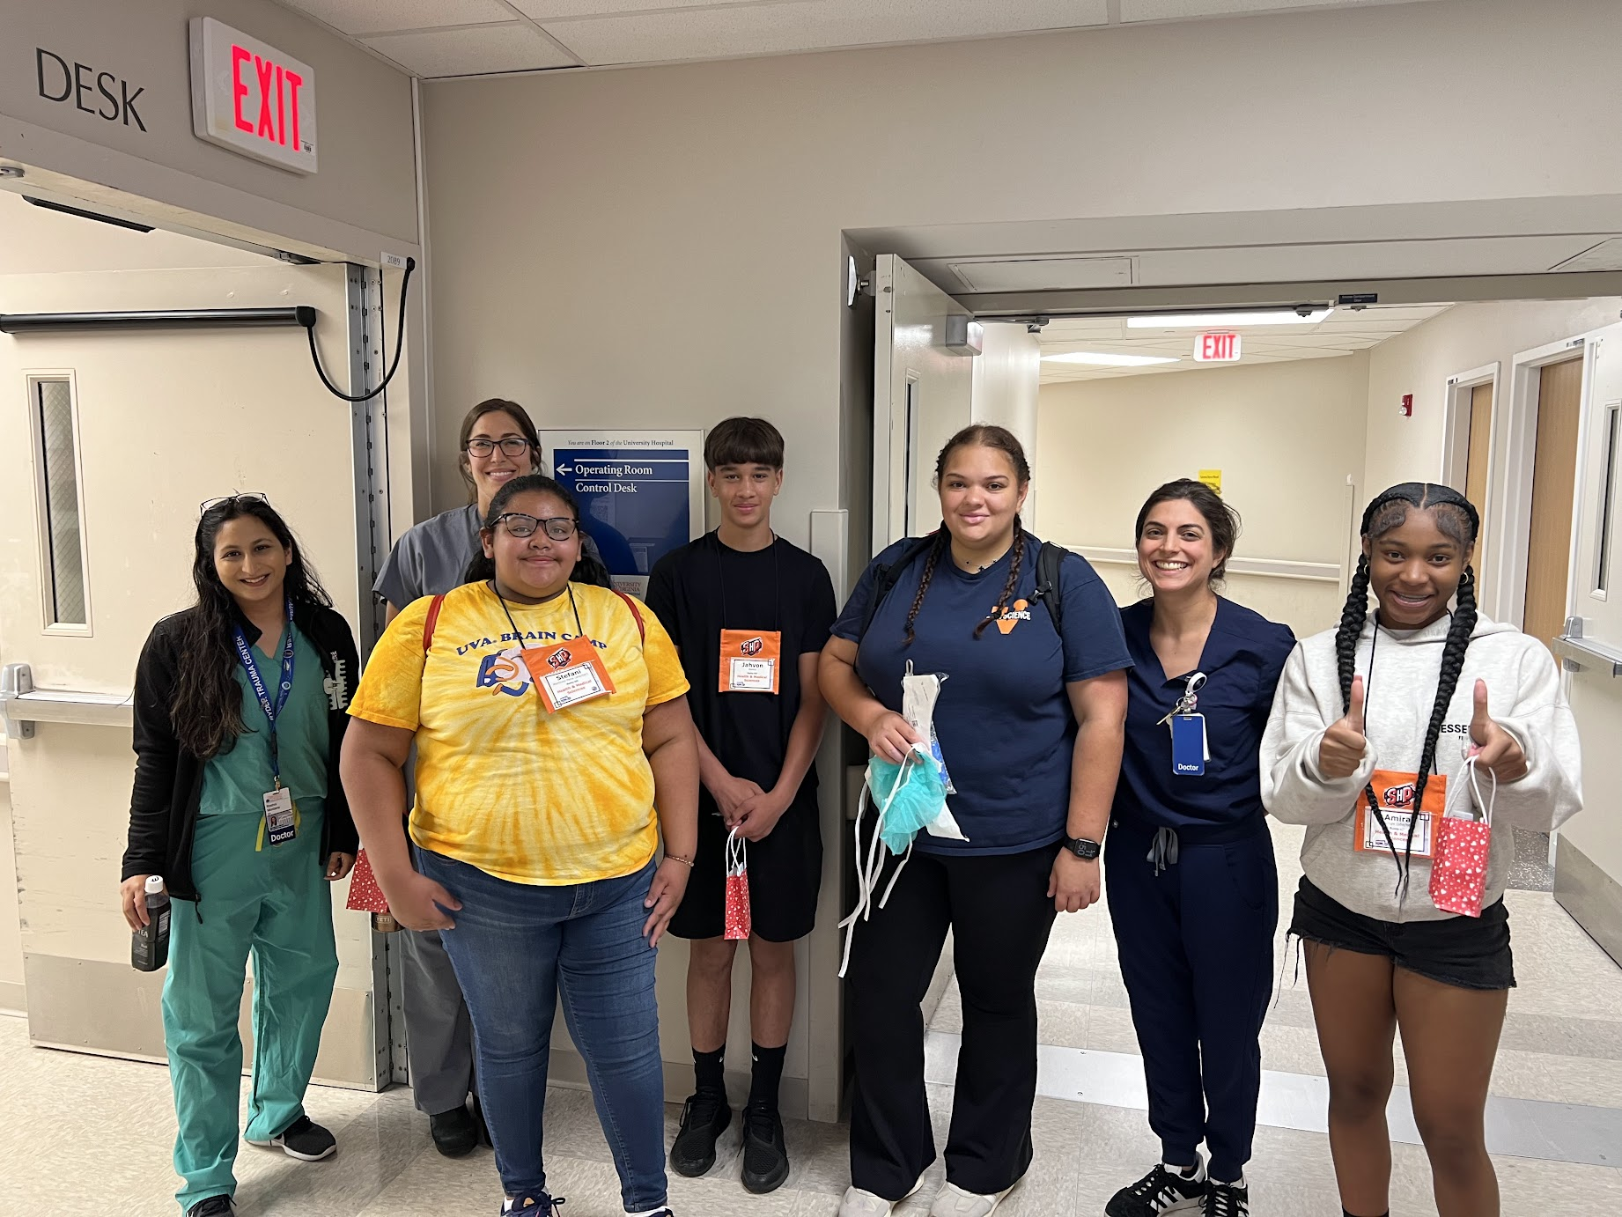
Department of Anesthesiology faculty and residents with Starr Hill students

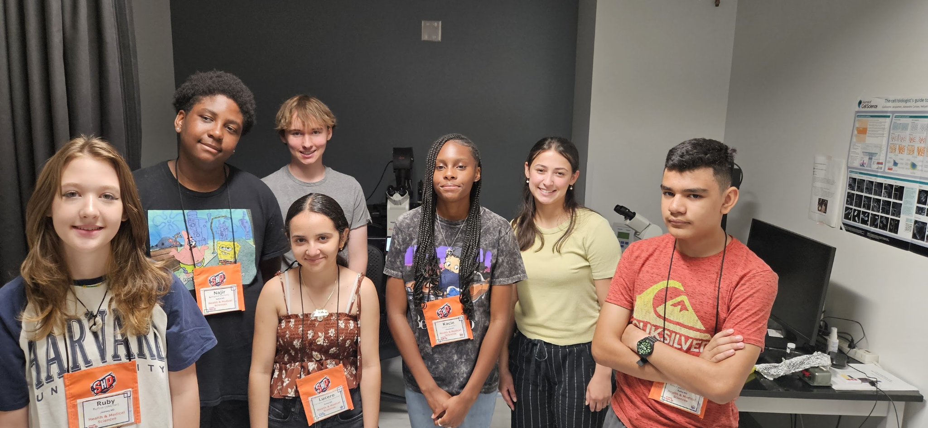
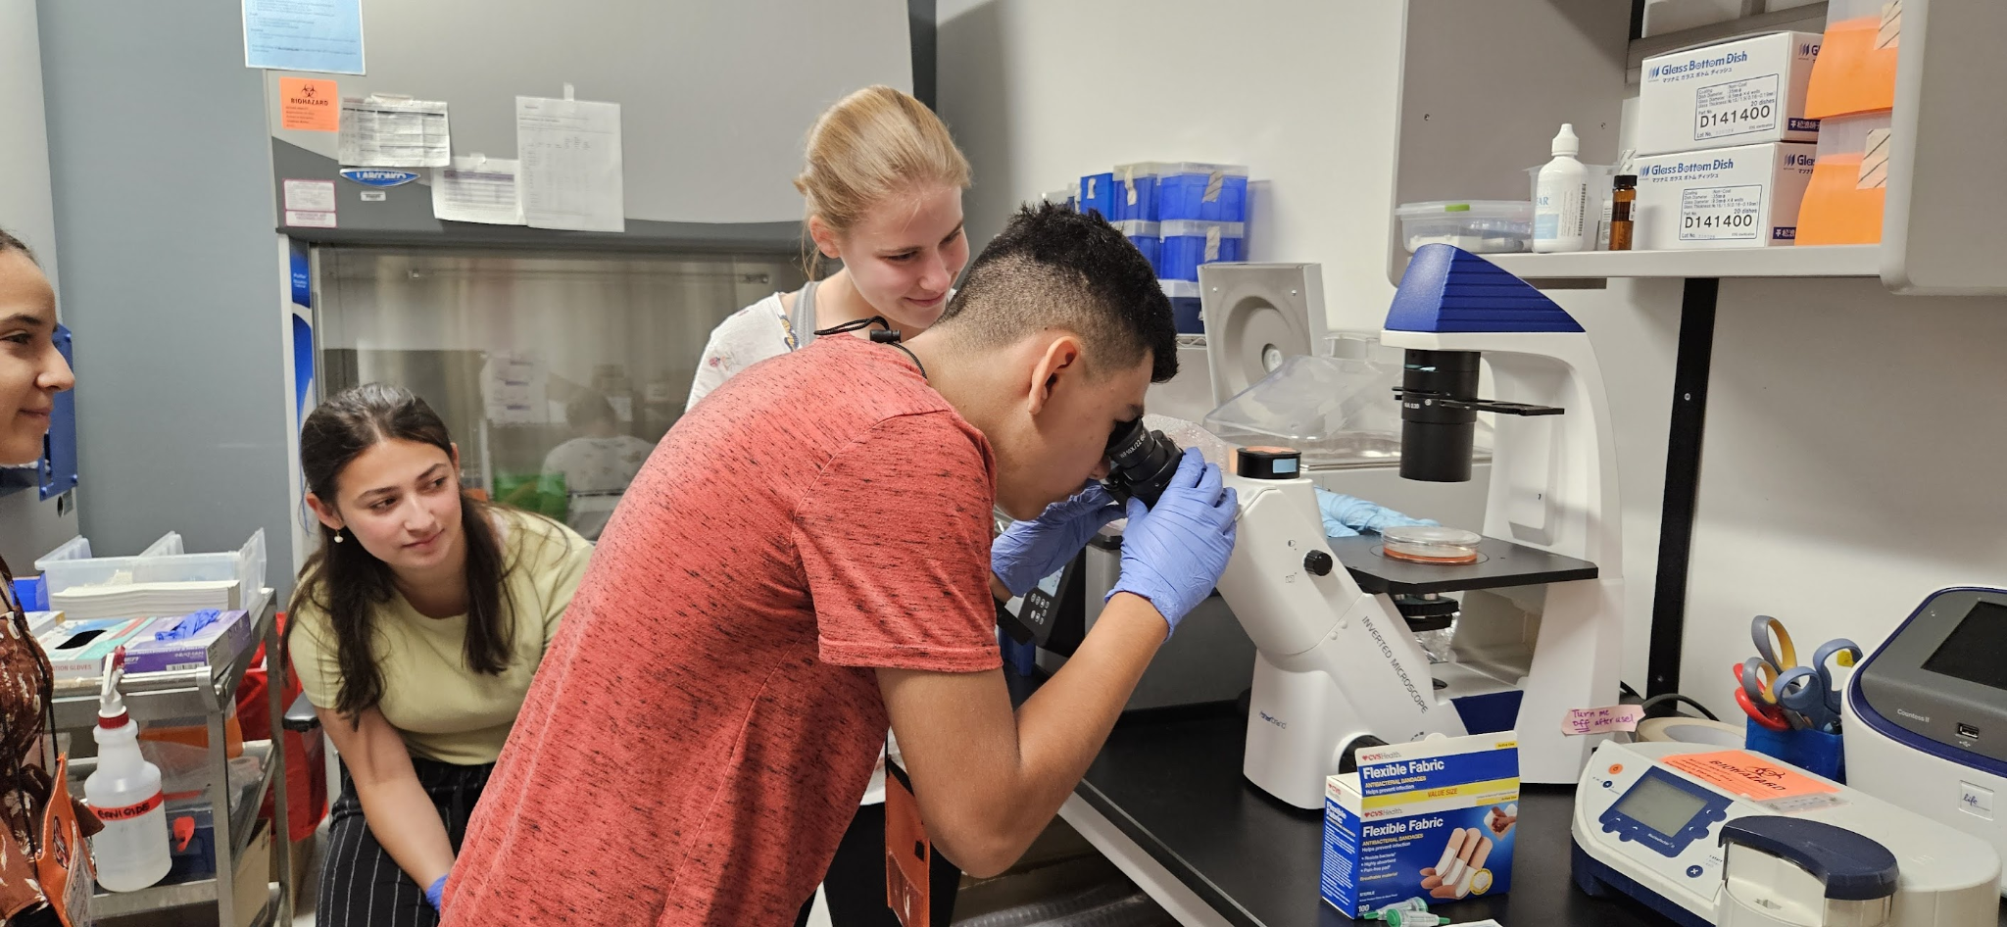

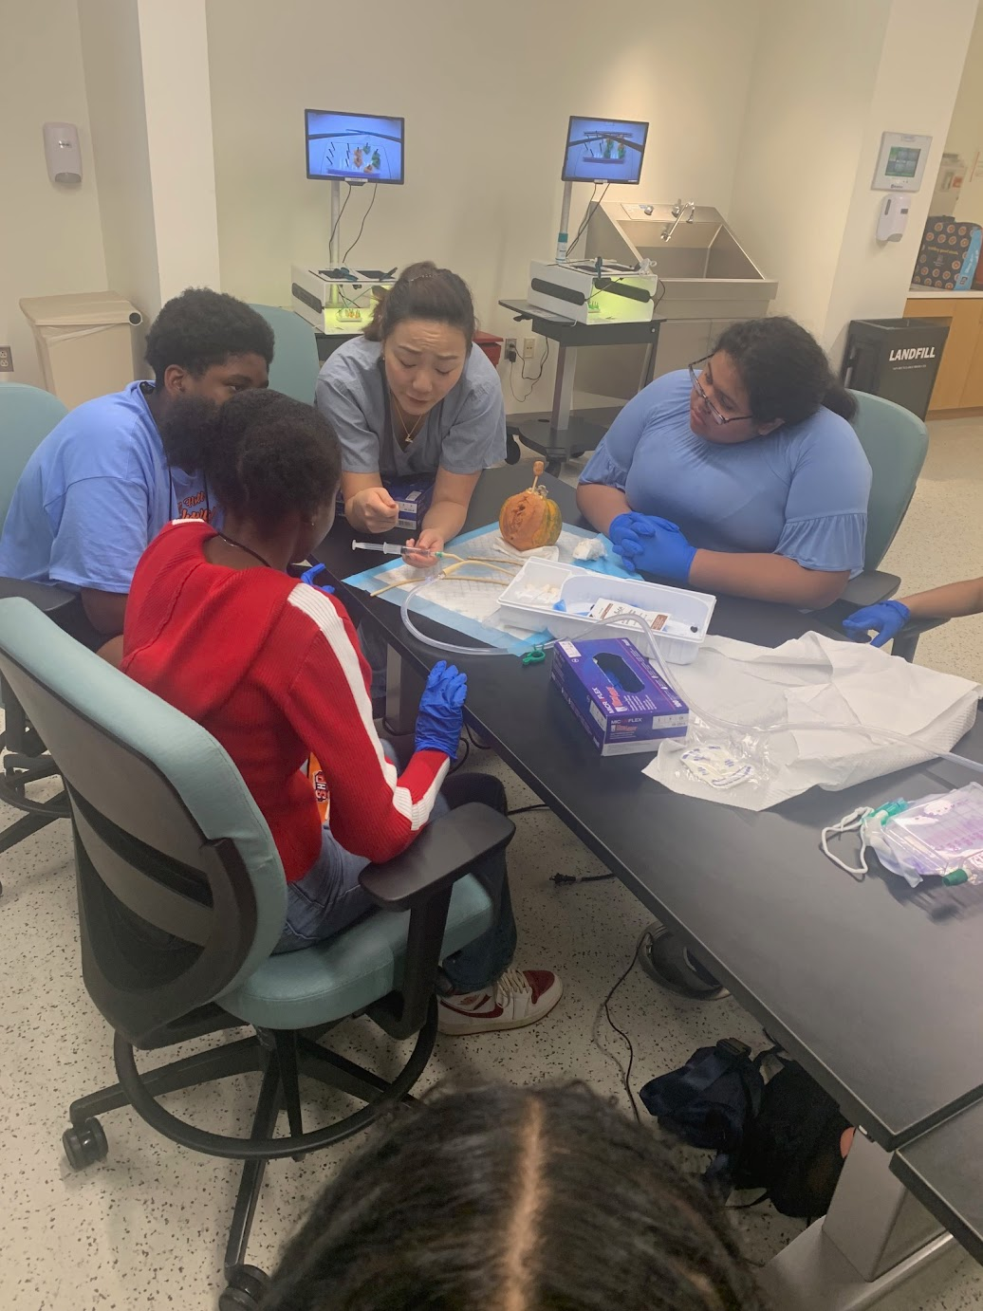
Department of Urology, Acorn squash modeling female catheter placement

