**Cancer Center Seminar**

**Hybrid Event**

**Friday, June 28, 2024**   
**12:30- 1:30 p.m.**

*Lunch will be served from noon -12:30 p.m.

**Pinn Hall, Room 1014\***  
or

[Click here to join via Zoom](https://virginia.zoom.us/j/97264770406?pwd=aWsyZkFhcWRJZHhCYUI0TlZucjRRUT09" \o "Click here to join via Zoom)

Meeting ID: 972 6477 0406

Passcode: 563016

**“Connecting the community to the lab and back again – why Oncologists should care about Insulin-resistance”**

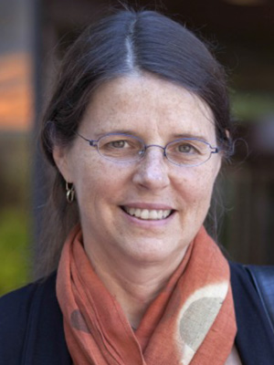

**Victoria Seewaldt, MD**

Ruth Zeigler Professor and Chair

Population Science

City of Hope

**Host: Roger Abounader, MD, PhD**

If you have questions or feedback, or if you would like to host a seminar in the future, please email Muzet Felgar at [mf8uh@uvahealth.org](mailto:mf8uh@uvahealth.org) or Roger Abounader at [ra6u@virginia.edu](mailto:ra6u@virginia.edu?subject=),  for available dates. Potential hosts are strongly encouraged to invite diverse speakers.

[UVA Comprehensive Cancer Center's Statement on Diversity](https://uvahealth.com/services/cancer/about)

The complete Seminar Series schedule is available [online](https://uvahealth.com/services/cancer-research/seminar-series).