Two students in the University of Virginia Master of Public Health Program have received prestigious national fellowships. Donavon Lea received the CDC Public Health Law Fellowship, and Abby Sacks accepted the HHS Health Communication Fellowship.
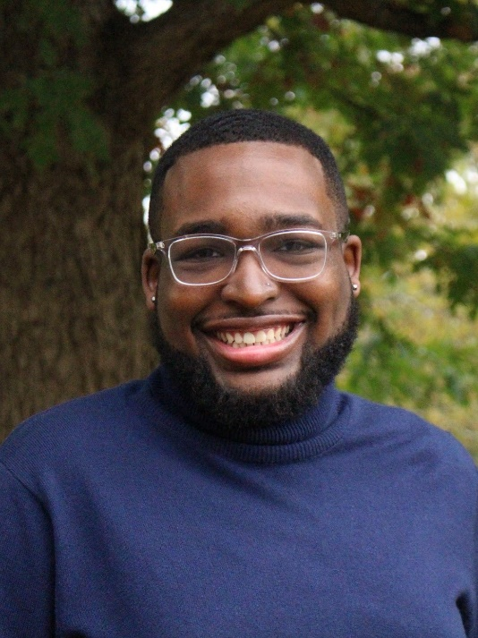
Donavon Lea’s fellowship is sponsored by CDC’s Public Health Law Program (PHLP) and ChangeLab Solutions. As the CDC describes it, “the Public Health Law Fellowship offers fellows on-the-job training to prepare them for careers in public health law or policy. The program aims to strengthen the public health law workforce by increasing diversity within the field and preparing the next generation of public health law professionals to respond to critical issues. Fellows are matched with host sites at state, tribal, local, or territorial health departments, CDC, or other public health law organizations that support work in the public health law and policy fields.”
In the MPH program, students complete a project or integrative learning experience (ILE) that demonstrates their foundational and concentration competencies. Donavon’s ILE is “The Impact of Legal Standards of Informed Consent on Maternal Mortality Rates in the US”. His project explores the relationship between the legal standard of medical informed consent a state uses (the "prudent patient" standard or "prudent physician" standard), and the potential impact it has on the rates of cesarean sections and maternal mortality in that state.
Donavon Lea, MPH student at UVA, received the CDC Public Health Law Fellowship.
From Virginia Beach, Virginia, Donavon graduated in spring of 2022 from UVA’s Batten School majoring in Public Policy and Leadership with a minor in Bioethics. After receiving his MPH this May, Donavon begins his fellowship this summer and is awaiting news on his placement. “After completing the fellowship, I plan to take a gap year before going to law school and becoming a lawyer.” Donavon said.

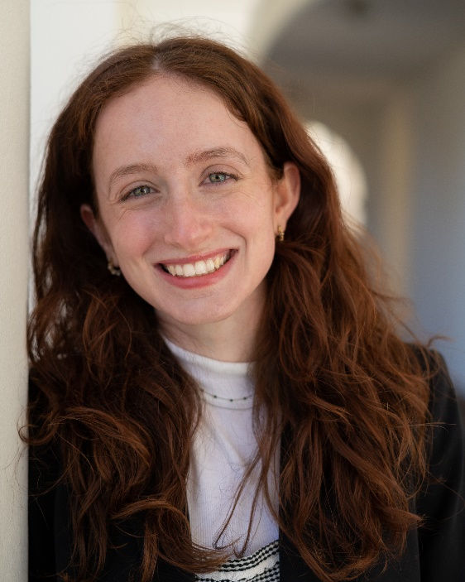
Abby Sacks’ fellowship was awarded by the Office of the Assistant Secretary for Health of the US Department of Health and Human Services located in Washington, D.C. According to the OASH job description, the position supports senior-level members of the OASH Communications team to develop and implement communications strategies; to conduct research and draft written pieces for publications; to support the social media and website team leader, and help promotion efforts for the OASH principals, initiatives and programs. “Previous health topic areas have included tobacco control, vaccinations, skin cancer prevention, physical activity and nutrition and emerging issues such as the Ebola outbreak.”
A native of Burke, Virginia, Abby holds a BA in psychology and media studies from UVA, and graduates in May with a Master of Public Health. Abby’s ILE is entitled, “What are the stress coping strategies of male and female first-year students?” In this qualitative study, she asked participants to create a collage and journal entry that represented how they responded to stress during their first year of college. She then analyzed the collages and write-ups for stressors and stress coping strategies comparing them by gender.
Abby Sacks, MPH student at UVA, accepted the HHS Health Communication Fellowship.
For her future career goals, Abby said, “I know I want to do health communications right now, and I expect to learn a lot about the public health/health communications career world during my fellowship. I think I want to work on helping public health institutions utilize visual media as a way to disseminate information, as a complement to traditional written media. I'm interested in pushing image-based health messages on social media to better reach populations like younger people or people whose first language is not English.”
Please join us in congratulating Abby and Donavon!
The mission of the Department of Public Health Sciences of the UVA School of Medicine is to provide excellence and leadership in innovative research, education, and community engagement strategies to advance clinical care, patient outcomes, and population health. PHS fosters research and educational collaborations with clinicians, researchers and faculty members across the University, other professionals, and communities to improve health equity and overall population health and well-being. The MPH degree program is one of several educational programs offered by the department.
Contact:
Charlotte B. Odom, MS
Administrative Generalist
Public Health Sciences
UVA School of Medicine
Cbo9f@virginia.edu
PHS Main: 434-924-8430

