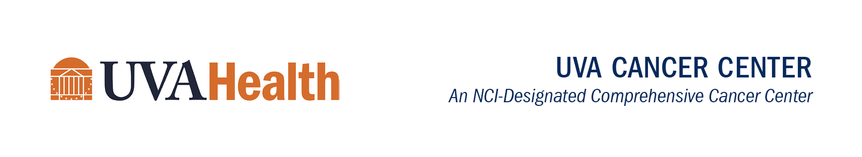
Cancer Center Seminar Series
Hybrid Event

Friday, March 24, 2023
12:30 - 1:30 p.m.

Pinn Hall, Room 1014*
or
Click here to join via Zoom
Meeting ID: 927 4018 2908
Passcode: 285036

*Lunch will be served from noon-12:30 p.m.

The Diverse Molecular and Cellular Biology of ADR-Ribosylation in Cancer
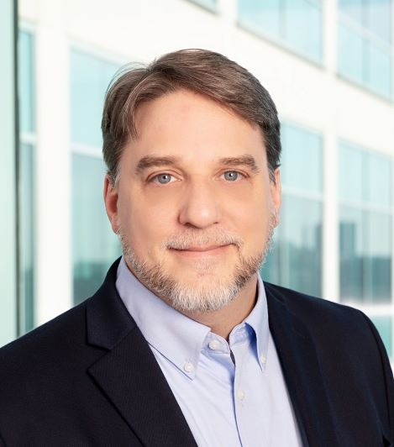

W. Lee Kraus, Ph.D.
Professor and Director, Cecil H. and Ida Green Center for Reproductive Biology Sciences
UT Southwestern Medical Center

Host: Daniel Gioeli, PhD

Five Reasons to Attend this Seminar:
- Learn about new aspects of ADP-ribosylation and the PARP family of enzymes that have not historically received much attention.
- Learn about the connections among NAD+ biosynthesis, NAD+ compartmentalization, and the functions of nuclear and cytoplasmic ADP-ribosyl transferases.
- Learn how PARP enzymes and ADP-ribosylation are providing new therapeutic opportunities in oncology.
- Hear from a thought leader in the field, who has helped move the field beyond PARP1 and DNA repair, developed new technologies to study ADP-ribosylation, and founded two biotech companies to target the enzymology of ADP-ribosylation in cancers.
- See why PARPs and ADP-ribosylation are fun!
If you have questions or feedback, or if you would like to host a seminar in the future, please email Jane Heblich at eh6k@virginia.edu for available dates. Potential hosts are strongly encouraged to invite diverse speakers.

UVA Comprehensive Cancer Center's Statement on Diversity

The complete Seminar Series schedule is available online.

