Four Interdisciplinary Teams are Awarded $100,000 Seed grants to support projects focused on immunology, imaging, and informatics in precision immunomedicine (iPRIME) for Cardiovascular Disease by the University-funded iPRIME P2PE initiative.
Learn more at the iPRIME website, iprime.virginia.edu.
Tick Bite Exposure and Coronary Artery Disease Risk
Loren Erickson, PhD, Department of Microbiology, Immunology, and Cancer Biology, Beirne B. Carter Center for Immunology Research, School of Medicine
Richard Flowers, MD, Department of Dermatology, School of Medicine
Jeff Wilson, MD, PhD, Department of Medicine, Allergy Division, Beirne B. Carter Center for Immunology Research, School of Medicine
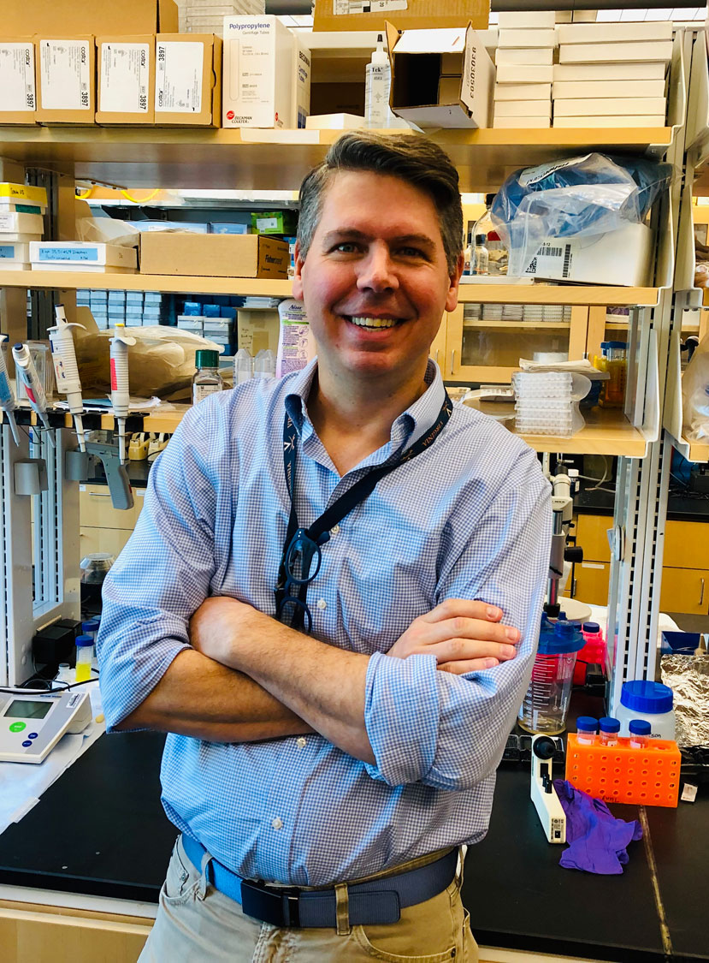

Loren Erickson PhD

Richard Flowers, MD

Jeff Wilson, MD, PhD

Ensuring Fairness and Robustness of Immunology Data
Aidong Zhang, PhD, Professor of Computer Science, Biomedical Engineering, and Data Science
Ani Manichaikul, PhD, Center for Public Health Genomics and Department of Public Health Sciences
Aidong Zhang, PhD PhD

Ani Manichaikul, PhD

Impact of sodium-glucose cotransporter 2 inhibitors on systemic inflammation in women with coronary microvascular disease
Patricia Rodriguez-Lozano, MD, Director of Women's Heart Health Program
Department of Medicine, Cardiology
Mete Civelek, PhD, Department of Biomedical Engineering, Center for Public Health Genomics

Mete Civelek, PhD

Patricia Rodríguez-Lozano, MD, PhD

Integrative single-nucleus and spatial profiling analysis to identify novel biomarkers of chronic inflammatory dilated cardiomyopathy
Clint L. Miller, PhD, Center for Public Health Genomics, Department of Public Health Sciences, School of Medicine
Sula Mazimba, MD, Heart and Vascular Center, Division of Cardiovascular Medicine, School of Medicine
Clint L. Miller, PhD
Sula Mazimba, MD

