Dolen Perkins-Valdez, Ph.D., Educator and New York Times Bestselling Author of Take My Hand joined UVA’s Department of Obstetrics and Gynecology Faculty, Residents, Fellows and learners in a discussion of her most recent book. Take My Hand is a novel based on the true story of the Relf sisters who at ages 14 and 16 were sterilized in 1973 Montgomery, Alabama. Their landmark case, Relf v Weinberger, brought to light decades of sterilization practices upon black and indigenous women funded with federal dollars. Through this lawsuit significant changes to State and Federal funding guidelines were made including the current State of Virginia Medicaid Sterilization Consent form which requires a 30 day waiting period from the time of consent to surgery.
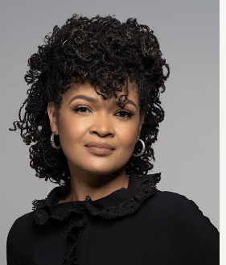
Building upon this historical framework Dr. Perkins-Valdez’s novel invites readers to reflect on how history influences the perspectives of black women today as they seek medical care. Take My Hand’s themes of empathy, responsibility and redemption created many points of connection within UVA OBGYN team members as they discussed bodily autonomy, advocacy and the pitfalls of good intentions with the author.
Dr. Dolen Perkins-Valdez is Associate Professor of Literature at American University and New York Times Best Selling author for her books Wench and Balm.

