2022 Dr. Henry Harrison Wilson, Jr. Everyday Humanism in Medicine Award Recipients

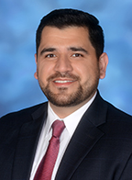
Dr. Yasir Abdul-Rahman (Family Medicine)

There were so many moments during my family medicine rotation where I witnessed compassion and medical humanism in Dr. Abdul-Rahman. One moment stuck out to me, and I felt it best illustrates the kind of physician and person he is -- the kind who will say "we're family!" to his patients and actually mean it. Towards the end of my rotation, we had a new patient come in and I actually recognized her from 3 weeks prior when she brought her daughter for a well child check. When we were pre-charting for her, we learned she hadn’t seen a PCP in years, her most recent hospitalization being a few years prior for a heroin OD. Dr. Abdul-Rahman made it clear to me before and throughout this visit that it would be our goal to make sure this patient felt seen, heard, and un-judged. If we didn’t meet her where she was at, she could very well not return and fall further behind in her health maintenance. It's this commitment to building trust, making an effort to know his patients as whole persons, and seeing someone's suffering and doing something about it (healing!) that makes Dr. Abdul-Rahman so deserving of this award.

Dr. Emma Trachman (Internal Medicine)

I watched her protect a patient's right to get a medical procedure done after discharge. She worked with the police to ensure that this patient would be able to have access to the care they needed and acted in the best interest of the patient in a situation that may have compromised the patient's overall health and well-being. Without hesitation, she jumped to make sure that the police understood the patient's circumstances. Emma displays model behavior for medical students. Outside of this specific situation, I could tell that she always had in mind the best interests of not only the patients but her colleagues as well. I admire her tenacity and drive to better the world we live in.

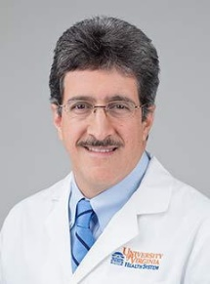
Dr. Max Luna (Cardiovascular Medicine)

Dr. Luna is a tremendous force in the community. His compassion and genuine interest in helping improve Latinx community health is inspiring. During the COVID pandemic he organized COVID testing events to help make tests accessible to the community. When the COVID vaccines came out, he organized community vaccination events to help bring vaccines to the historically marginalized Latinx community that would otherwise not have access. He would even knock door to door, to help fight misinformation and encourage people to get the COVID vaccine. Even when community pets would bark at him, he would persist. He is a true symbol of leadership, excellent character, humility, and true compassion. Not only this, but he encourages students to always be themselves. He has taught me the importance of staying true to myself, despite facing adversity. As a Latina medical student, I aspire to be like Dr. Luna. He always states he serves the community because he loves helping the community. He is an inspiration to us all and serves as a reminder of the true purpose of medicine which is to help people in need. Dr. Luna is a caring and compassionate provider and has even helped me during my personal times of illness. He embodies all of the characteristics for the Dr. Henry Harrison Wilson, Jr. Everyday Humanism in Medicine Award. It is rare to see Latinx leadership be recognized in the health system and I would like to nominate him for this award.

