Division of Nephrology Medicine in Motion (MIM) Submission_20220812
TOTAL ITEMS: 1
--
TITLE:
Co

DESCIPTION: (<200 Character count)
Dr. Corey Cavanaugh, M.D. Assistant Professor, Division of Nephrology, Department of Medicine was appointed to serve on the 2023 American Society of Nephrology (ASN) Kidney Week Education Committee. This committee is responsible for the educational content of the annual meeting of the ASN attended by 14,000 nephrologists from around the world.
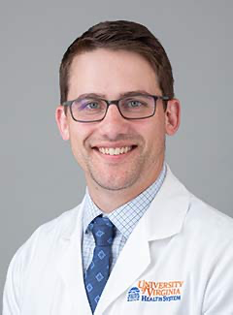
FACULTY DETAILS:
Corey Cavanaugh, M.D.
Assistant Professor, Medicine: Nephrology

