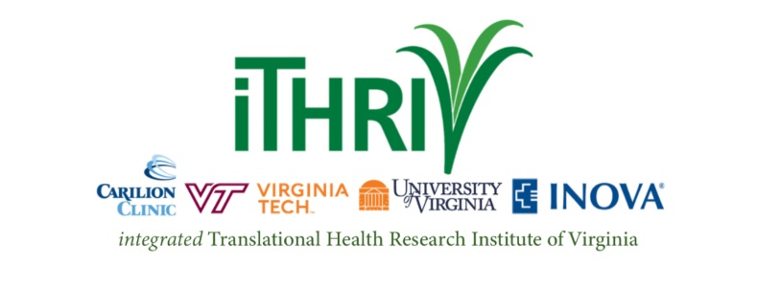
iTHRIV is Pleased to Announce Two New Funding Opportunities!

Pilot Translational and Clinical Studies Program
The iTHRIV Pilot Studies Program announces $200,000 in available funding to support innovative approaches to clinical and translational research across the iTHRIV partner institutions. Proposals can include the full range of translation from the laboratory to the clinical area. For more detailed information and access to all required forms please review the full RFP at this link.
Funding Available: Single iTHRIV Institution proposals can request $25,000 and Multi-iTHRIV Institution proposals can request $50,000. Projects are required to be completed within one year.

Community Organization & Research Institution Partnership
The iTHRIV Community Collaboration Core announces $80,000 in funding to support community organization and iTHRIV research institution partnership projects. Proposed community engaged research projects may address direct health outcomes, health disparities, and/ or social determinants of health. For more detailed information and access to all required forms please review the full RFP at this link.

Funding Available: Proposals may request $40,000. Projects are required to be completed within one year.

Proposals Due: Monday, August 29th, 2022 by 5 pm

Questions? Please contact iTHRIV: iTHRIVAdmin@hscmail.mcc.virginia.edu

